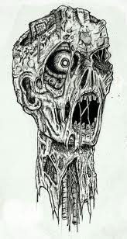

**Arguing for:** Urban Survival Rural Survival

(circle one)

The debate will consist of three rounds. Round 1 will be 3 minute opening statements from, Round 2 will be a rebuttal arguments, and Round 3 will be closing statements.

**Requirements:**

**Opening Statement: 3 minutes**

* Three main arguments for your topic
* One argument that counters a primary argument of the opposite side
* At least one direct quote with cited sources

**Rebuttal: 2 minutes**

* Will need to be prepared on the spot.
* Have arguments ready to counter what the other side said during the opening statement.

**Closing Statement: 2 minutes**

* Sum up all of your sides arguments.
* Point out the flaws with the other sides argument.
* Have a closing sentence that resonates with your audience.

Names_______________________________________________________

**Urban vs. Rural Debate**

Opening Statement:

Possible Counter Arguments for Rebuttal:

Closing Statement: