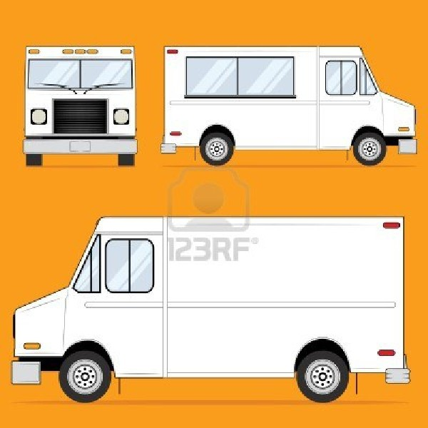

Truck’s Name

Business Plan

Owner’s Names

1. Mission Statement
2. Company Description
3. Organization and Management
4. Services and Products
5. Market Analysis
6. Marketing and Sales
7. Funding Requests
8. Cost Analysis Table
9. Appendix
   1. Recipe
   2. Company Logo
   3. Truck Design
   4. Sign Design
   5. Swag Design
   6. Sample Menu
   7. Food Handlers Cards

Table of Contents

Social Mission

* Insert Social Mission Statement Here

Product Mission

* Insert Product Mission Statement Here

Economic Mission

* Insert Economic Mission Statement Here

Mission Statement

Food Cart Name

About our Food

* What do you serve?
* What kind of demand is there for your food truck?
* How does your menu meet the community’s needs?

About our Truck

* What is unique about your food truck?
* How will you attract customers to your truck?

About our Business

* What competitive advantages do you have over other food trucks? (location, value, expertise, efficiency, a unique menu)
* What are your short-term and long-term goals for your food truck?

Company Description

Company Description

Meet the Owners:

* List of the owners.

Job Descriptions:

* What is each person’s job description? What are his/her responsibilities?

Compensation:

* What percentage of the company does each person hold?

Organization & Management

Organization & Management

All About our Food

* What does your food truck offer? What is your food truck’s signature item?
* What advantages does your menu offer over other trucks?
* Could you open additional trucks, offer franchises, or create a brick and mortar location in the future?

Services & Products

Services & Products

The Food Truck Industry

* How big is the food truck industry?
* What type of growth has the industry seen in the past few years?

Our Target Market

* What customers make up your target market? What characteristics do they share?
* When will your customers buy from you? What challenges will you face in making sales?

Our Competitive Edge

* What trucks will you compete against? Assess the competition by looking at each truck’s advertising methods, strengths and weaknesses?
* How will you price items on your menu? Will there be any discounts?

Market Analysis

Market Analysis

Marketing Strategy

* How will you break into the food truck market?
* How can you encourage customers to return?
* What will your marketing efforts cost?

Sales Strategy

* What will the average order cost at your truck?
* How many days per year will you sell?

Marketing & Sales

Marketing & Sales

Start Up Costs

* Highlight what some of the major start up costs will be.
* Reference the Cost Analysis Table on the next page.

Financial Needs

* How do you intend to repay any loans you receive?
* What percentage of the profits will your investors receive in return?

Reasons to Invest

* What opportunities will funding provide for your business?

Funding Request

Funding Request

Fill out the rest of this table with items you will need for your cart specifically. Do not forget to include cooking utensils, special equipment, paper products, utensils for customers, groceries, and marketing materials.

|  |  |  |
| --- | --- | --- |
| **Item** | **Cost per Item** | **Total Cost** |
| Food Truck |  |  |
| Truck Wrap |  |  |
| Register/POS System |  |  |
| Specialty Equipment | n/a |  |
| Insurance | n/a |  |
| Licenses and Permits | n/a |  |
| Staff Members | Hourly Salary: |  |
| Initial Food Purchase | n/a |  |
| Initial Utensils and Paper Goods Purchase | n/a |  |
| Vehicle Inspection |  |  |
| Maintenance/Repairs |  |  |
| Fuel |  |  |
|  |  |  |
|  |  |  |
|  |  |  |
|  |  |  |
|  |  |  |
|  |  |  |
|  |  |  |
|  |  |  |

Cost Analysis

Appendices

1. Recipe
2. Company Logo
3. Truck Design
4. Sign Design
5. Swag Design
6. Sample Menu
7. Food Handlers Cards

Insert your recipe for your signature item here. You may want to include pictures of your food as well.

Recipe

At least two designs need to be in this section. If your designs are too big to fit on the page, take a picture and put it on this page.

Company Logo

Truck Design

At least two designs need to be in this section. If your signs are too big to fit on the page, take a picture and put it on this page. Have the real sign with you as well when presenting your plan.

Sign Design

At least two designs need to be in this section. If your designs are too big to fit on the page, take a picture and put it on this page. Have the actual swag item available at panels

Swag Design

Insert sample menu here.

Sample Menu

Insert copies of everyone’s food handler’s cards here.

Food Handler’s Cards